Parallel Programming Exercise 4 – 7

Author: | 李昌樺 (R11525006@ntu.edu.tw)
Student ID | R11525006
Department | Engineering Science and Ocean Engineering
(If you and your team member contribute equally, you can use (co-first author), after each name.)

Problem and Proposed Approach
(Brief your problem, and give your idea or concept of how you design your program.)
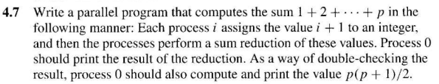
- 初始化mpi環境 => 處理器id=rank , 處理器總數=size
- 設定好1:n個連續整數，將其依照處理器的個數進行平行化分配。
- 每個處理器都運算自己的local sum
- 通過MPI_REDEUCE 將local sum 回收至 rank0的global sum
- Rank0 通過 n*(n+1)/2的公式得到計算值，與global sum進行比對

Theoretical Analysis Model
(Try to give the time complexity of the algorithm, and analyze your program with iso-efficiency metrics)

Performance Benchmark
(Give your idea or concept of how you design your program.)

Table 1. The execution time
Processors | 1 | 2 | 3 | 4 | 5 | 6 | 7 | 8
Real execution time | 0.000944 | 0.000738 | 0.000712 | 0.001225 | 0.002450 | 0.002613 | 0.002591 | 0.003067
Estimate execution  time | 0 | 0 | 0 | 0 | 0 | 0 | 0 | 0
Speedup | 1 | 1.279133 | 1.325843 | 0.770612 | 0.385306 | 0.361271 | 0.364338 | 0.307793
Karp-flatt metrics |  | 0.563559 | 0.631356 | 1.396893 | 2.994174 | 3.121610 | 3.035487 | 3.570218

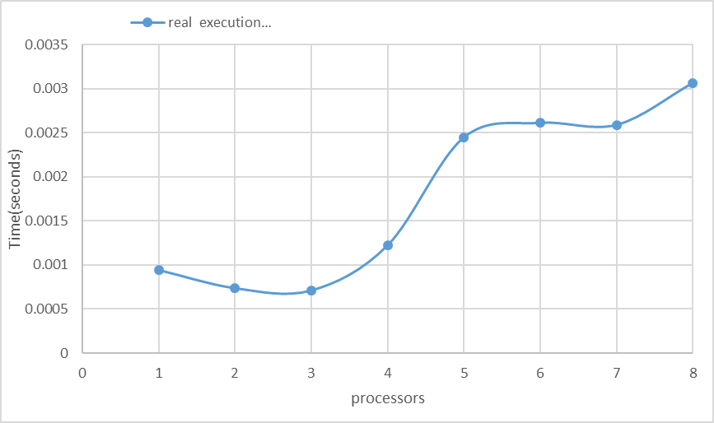
Figure 1. The performance of diagram

Conclusion and Discussion
(Discuss the following issues of your program)
- What is the speedup respect to the number of processors used?
Speedup在2、3顆處理器時雖然有上升但是幅度不多，第4顆以後則開始下降。
- How can you improve your program further more?
目前的平行化方式並沒有讓每個處理器拿到連續的數列，可能會導致快取記憶體需要重新抓資料，可以改變資料切割方式讓運算時間減少。
- How does the communication and cache affect the performance of your program?
溝通的部分只有用到reduce我主觀認為應該不會太過影響執行效率，但通過Karp-Flatt metrics的結果，可以發現溝通是導致處理器越多效率越滴下的原因，可能是因為資料量過小n只到1000。記憶體的部分則如上所述，需要改變資料分配型態。
- How does the Karp-Flatt metrics and Iso-efficiency metrics reveal?
Karp-Flatt metrics 明顯的有往上升的趨勢，代表著比起不可平行化的部分，溝通帶來
了很大的影響。或許是因為資料量不夠大，也可能是因為這問題本身
就能夠透過一個公式來解決不需要用到平行化。

Appendix(optional):
(If something else you want to append in this file, like picture of life game)

程式執行結果:
